BSc Computing Global Online Program
HLUM HTET AUNG
Web Technologies

Report Contents
Sapphire Fun Website Report 3
I. Sapphire Fun Games and Features 3
Mini-Games Section 3
Removal of Interactive Choice Based Story Games 3
Fun Fact Section 4
User Interface & Design Features 4
II. Sapphire Fun Webpages 4
Index 4
About Us 5
Mini Game Page 6
Fun Fact Page 7
III. Additional Features 7
Time Count Down 7
Scoring System 9
Audio System 10
Difficulty System 10
References 11

Sapphire Fun Website Report

Sapphire Fun Games and Features
Sapphire Fun includes many games and features for the users to enjoy spending time. The features can attract users to keep coming back, while games entertain the players. Regarding features, Sapphire Fun will include multiple features to keep the users entertained. Proposed features that are ensured to include in former implementation stage are as follows.

Mini-Games Section
Mini-Games are the core features that are planned to be implemented in the Sapphire Fun. In this report, each mini game included in the implementation stage will be mentioned with the reason why they were chosen.
- Tic Tac Toe – This game is the most common well-known foundation of mini games.
- Wordle Style Game – Wordle is one of the most played word games from New York Time and it is a must for a website featuring mini games.
- Whack-a-Mole – Whack a mole is a non-typical game in many websites, although it is a classic game among many other mini games.
- Reaction time test – This is a trendy fun exercise where you can test your reaction time as the color changes and stopwatch starts.
- Sudoku – This is the classic number game where many people like to play for brainstorming.

Removal of Interactive Choice Based Story Games
Sapphire will remove the story games from its game section due to the time constraints. Sapphire Fun initially intended to implement choice-based story games. However, due to time limitations and longer implementation time taken in the mini games for better experience the idea was abandoned for more realistic scope. In replacement of story games, 2 new mini games were added to ensure the visitors of the website still have 7 different mini games to choose from. These additional games are –
- Flappy Car – This is the car version of flappy bird where the car bounces between pipes.
- Memory Cards – Classic games of memory card game where you match two identical cards

Fun Fact Section
This feature is for the users to see the game reviews from other players before diving into the game and fun fact section is referenced from the Neal website (Neal, n.d.) where astronomy and deep-sea fun fact is widely known. This feature is a great way to improve user attraction.

User Interface & Design Features
The user interface and design features include navigation sidebar that is linked to other pages. It also includes responsive layout to work on both desktop full screen and small or cropped screens. This ensures that the website is responsive on both desktop and mobile. The website will feature sapphire themes with colors and effects. All of these features are included in order to attract users with a great UI/UX design.

Sapphire Fun Webpages
Below are the developed webpages of sapphire fun and the games using iframe as planned in part 1 report for better page optimization. Iframe allows sapphire fun to be able to play games on single page without the need to make each page for each game. This allows faster the fun website to as realistic as possible making it like the modern game websites like crazy games.
For more interactive the pages include relaxing balls floating around in the background with z-index -1. This makes sure these balls never overlap with the main contents of the page and ensure that the page background is dynamic and is fun looking.

Index
The main page of Sapphire Fun and it is inspired by the layout of crazy games.
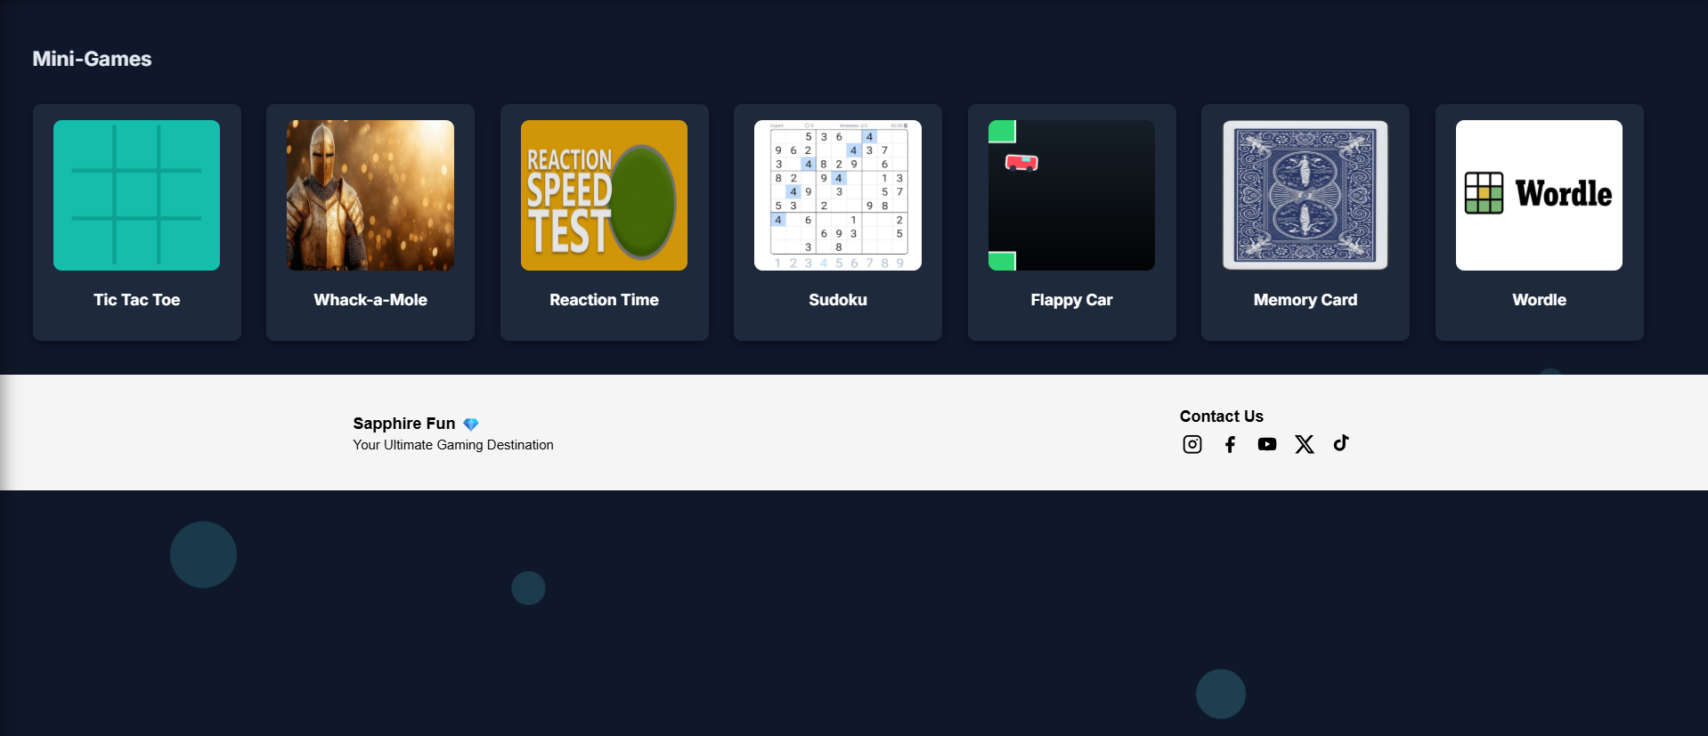
Figure IV-1 Index Page at 75%
Note: The page was zoomed out to 75% to ensure that all page contents are available in the screenshot. The design looks best 100%.
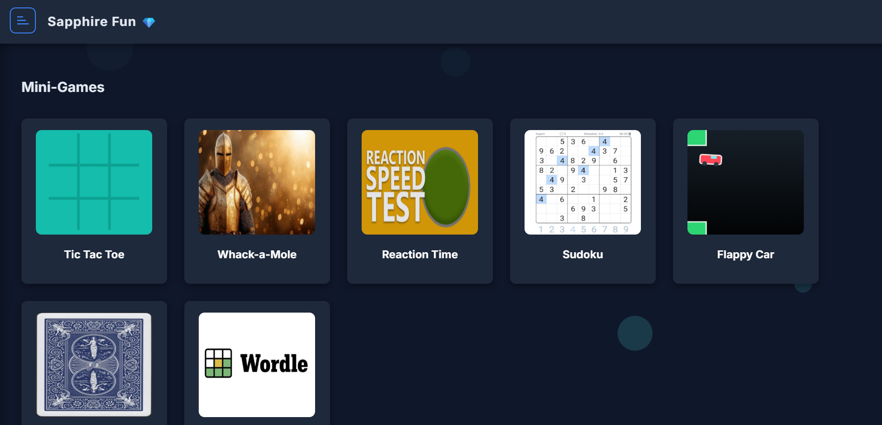
Figure IV-2 Index Page at 100%

About Us
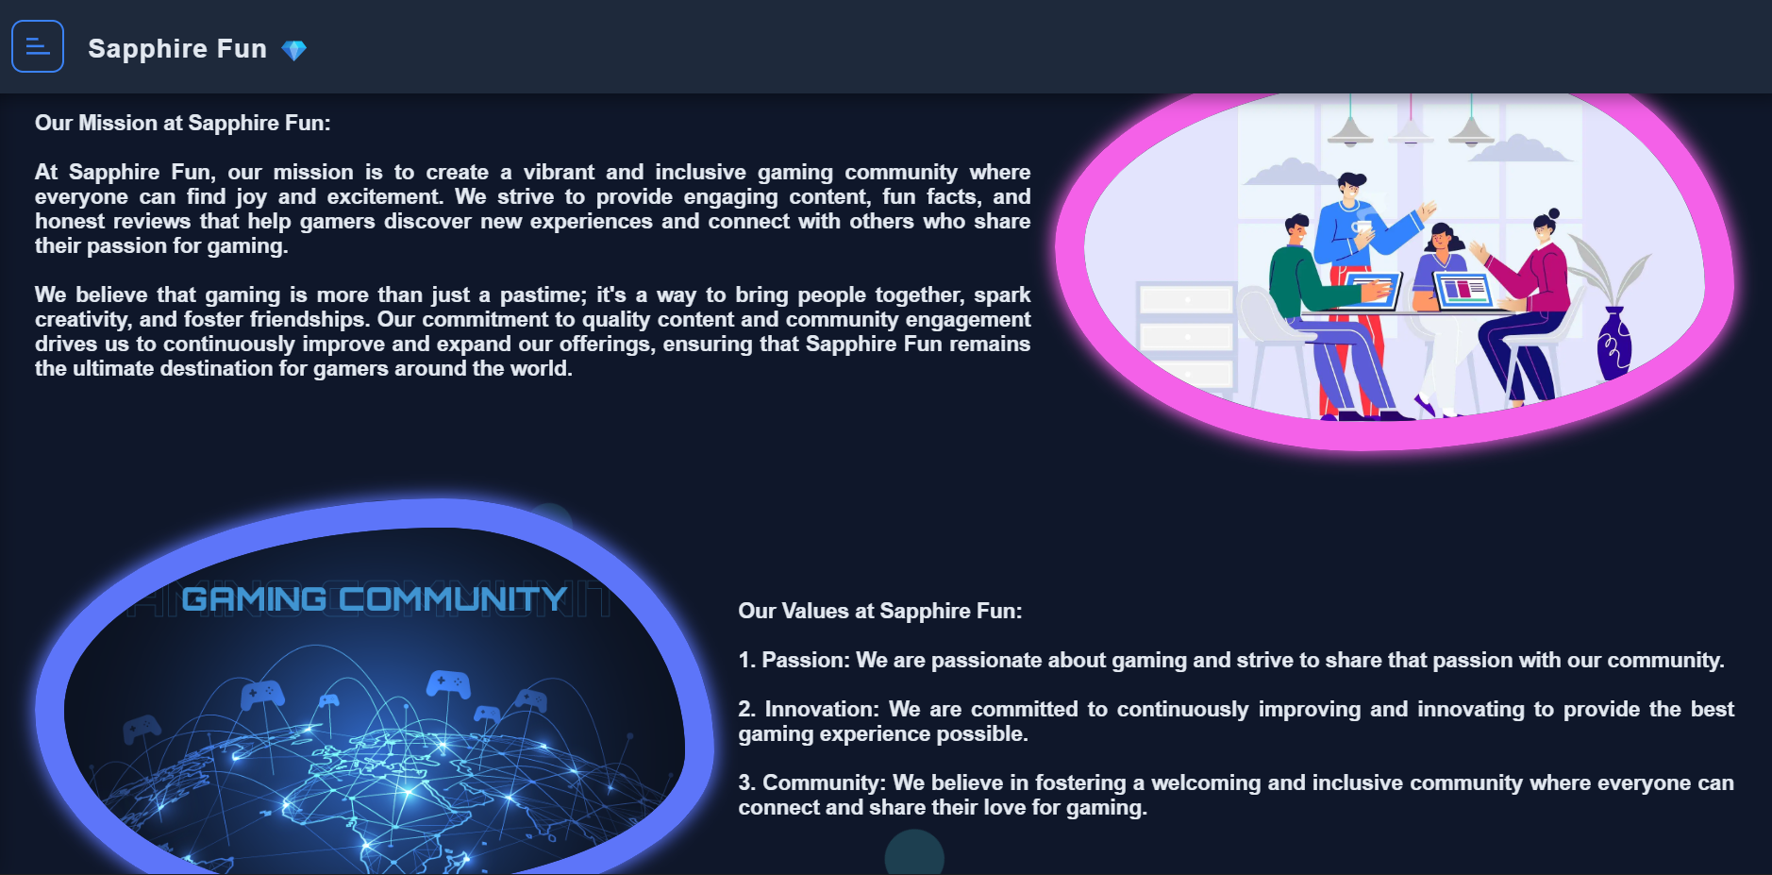
Figure IV-3 About Us Page
The page design was made to resemble as close as possible to the wireframe in Figma.

Mini Game Page
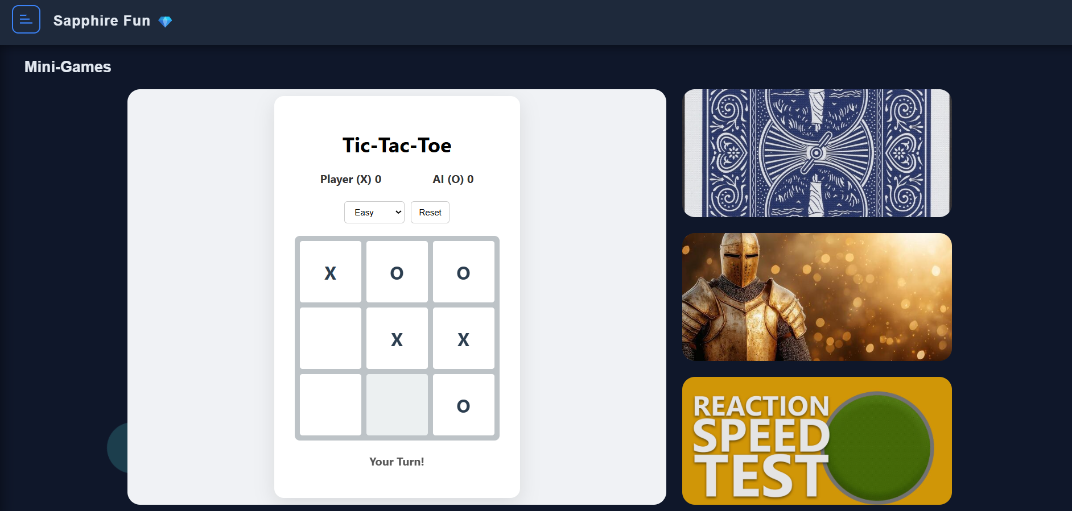
Figure IV-4 Mini Games Page at 100%
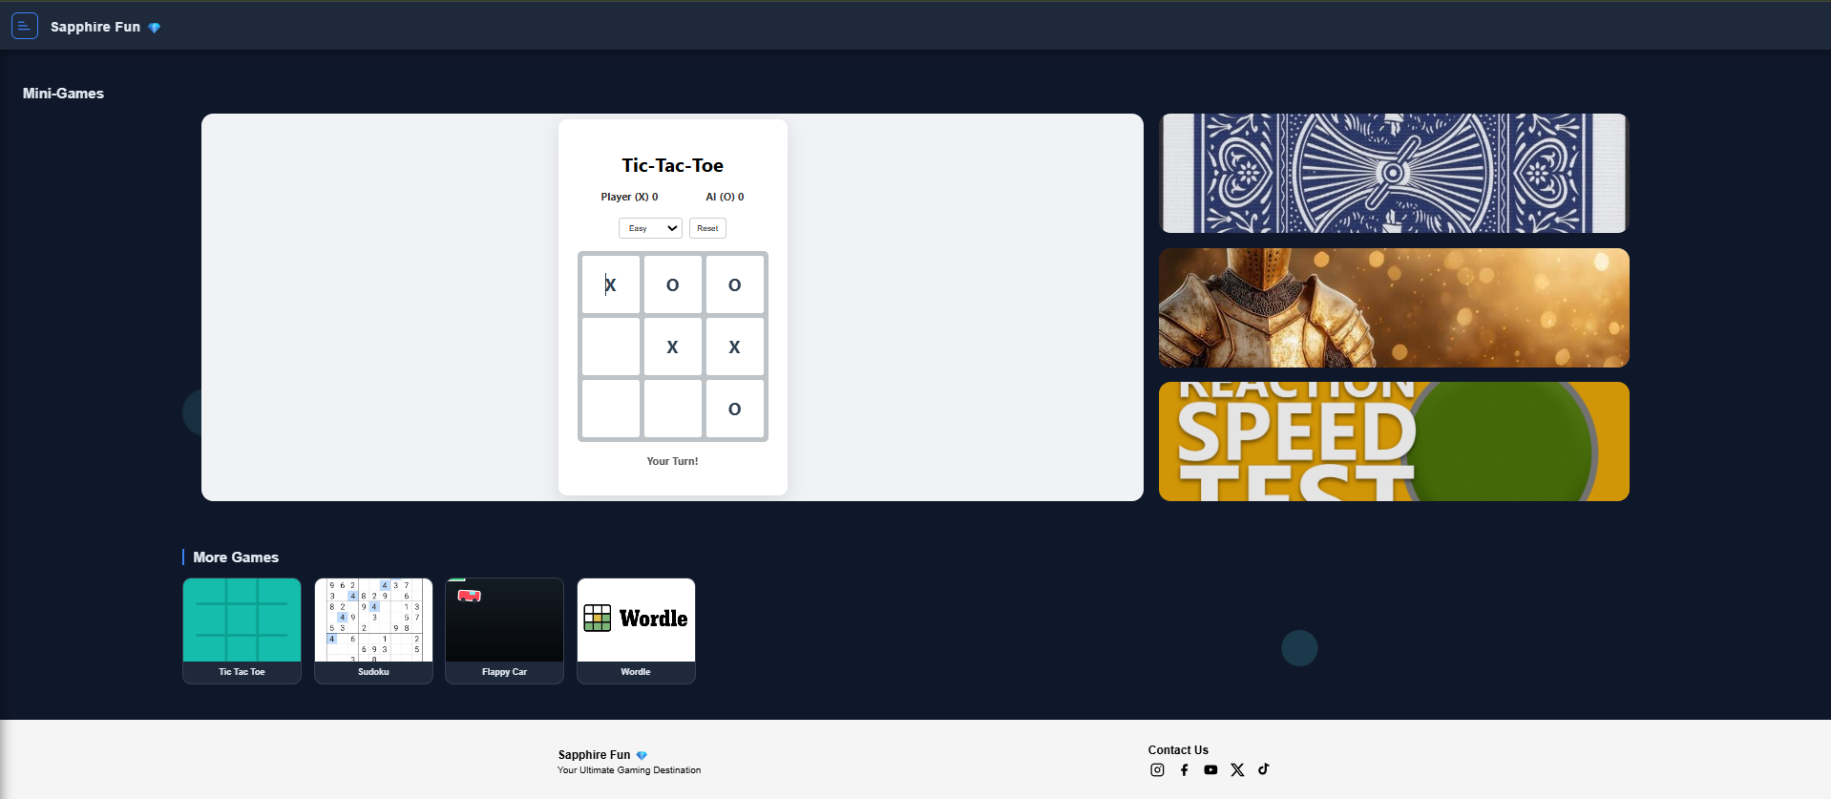
Figure IV-5 Mini-games page stretched out for full view
In the picture the tic tac toe game is opened with iframe so the website won’t need to shift around to each game pages and ensure that the games are opened in specific part of the page.

Fun Fact Page
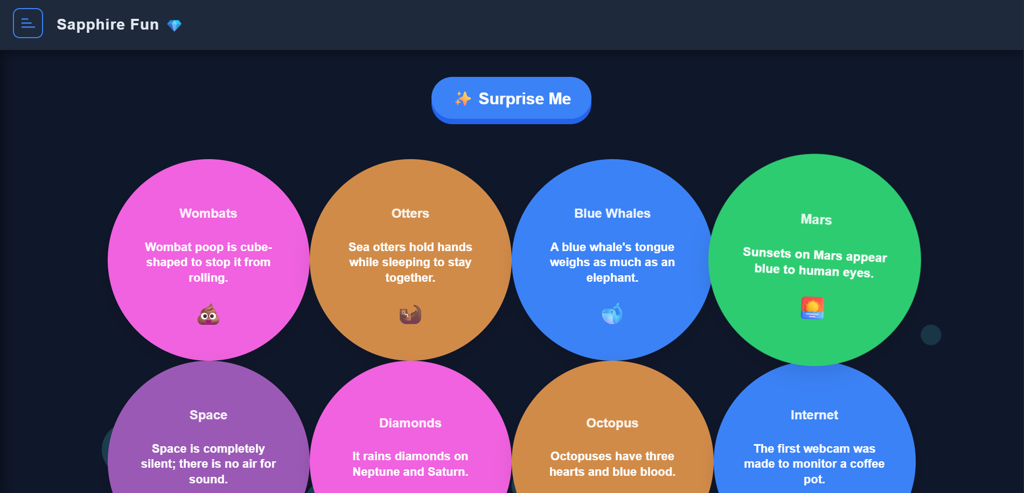
Figure IV-6 Fun Facts Page
The fun fact page was inspired by Neal. Fun websites, where their astronomy and deep-sea fun facts are well known due to their visual presentations. There are around 20 fun facts to choose from and the surprise me button will show the random fun fact from those 20. This is done using JavaScript random function.

Additional Features
From just the design more additional features such as time count down for games, scoring system, and audio features as flappy car background music were added for better immersion. The reference for these features is Moodle lectures.

Time Count Down
The time countdown for the games is added to ensure a little fun pressure on the users. The countdown will start as soon as the game starts in the whack a mole.
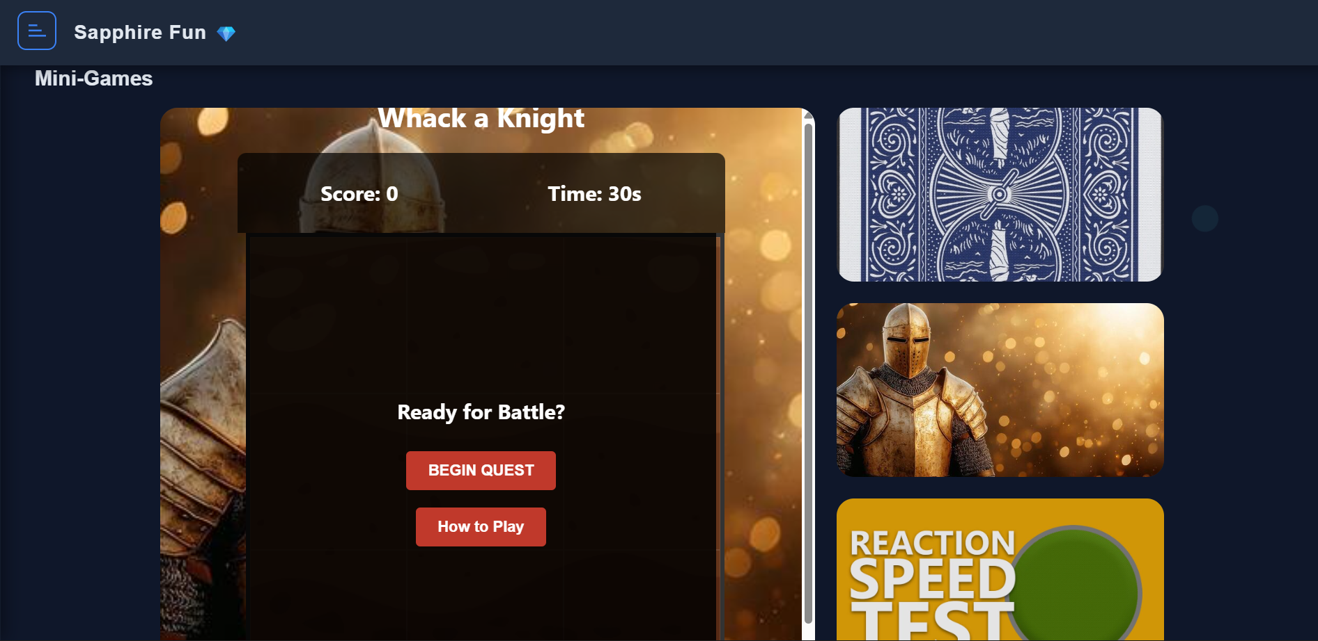
Figure V-1 Whack a mole time countdown and score
The score will start as soon as the game starts, and the game will stop as soon as the timer stops, and the high score will be stored in the local JavaScript. The score will be stored locally unless the website is restarted.
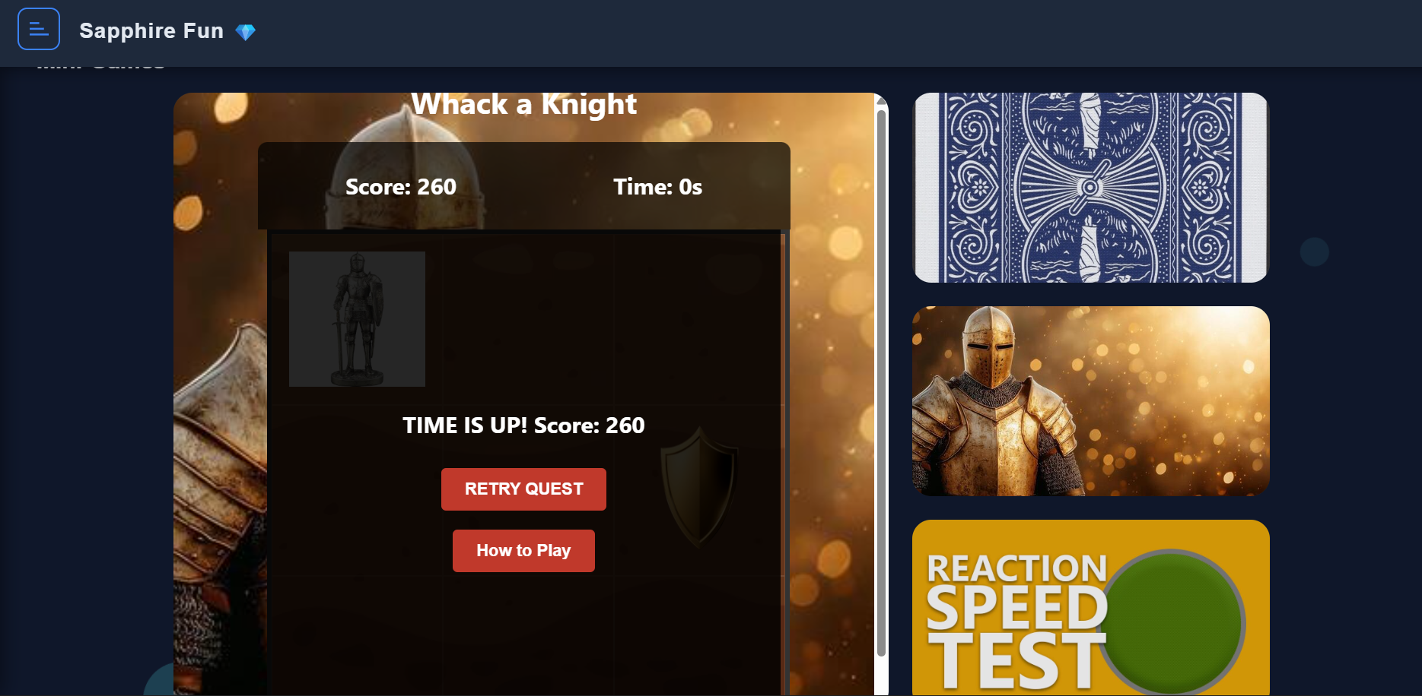
Figure V-2 Score system and time countdown system

Scoring System
The score for the Sapphire Fun website such as scores for whack a mole, flappy car, tic tac toe, etc. will have scoring system based on the local storage using JavaScript.
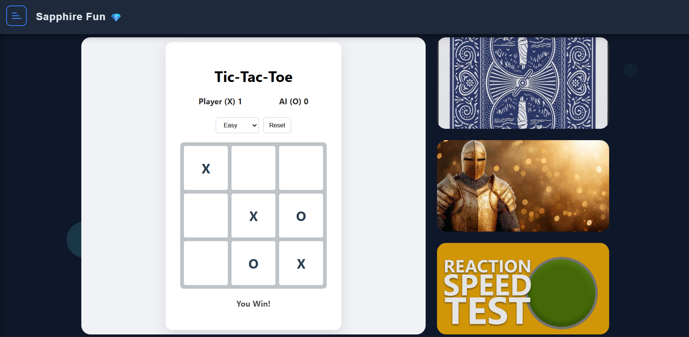
Figure V-3 Tic Tac Toe score system
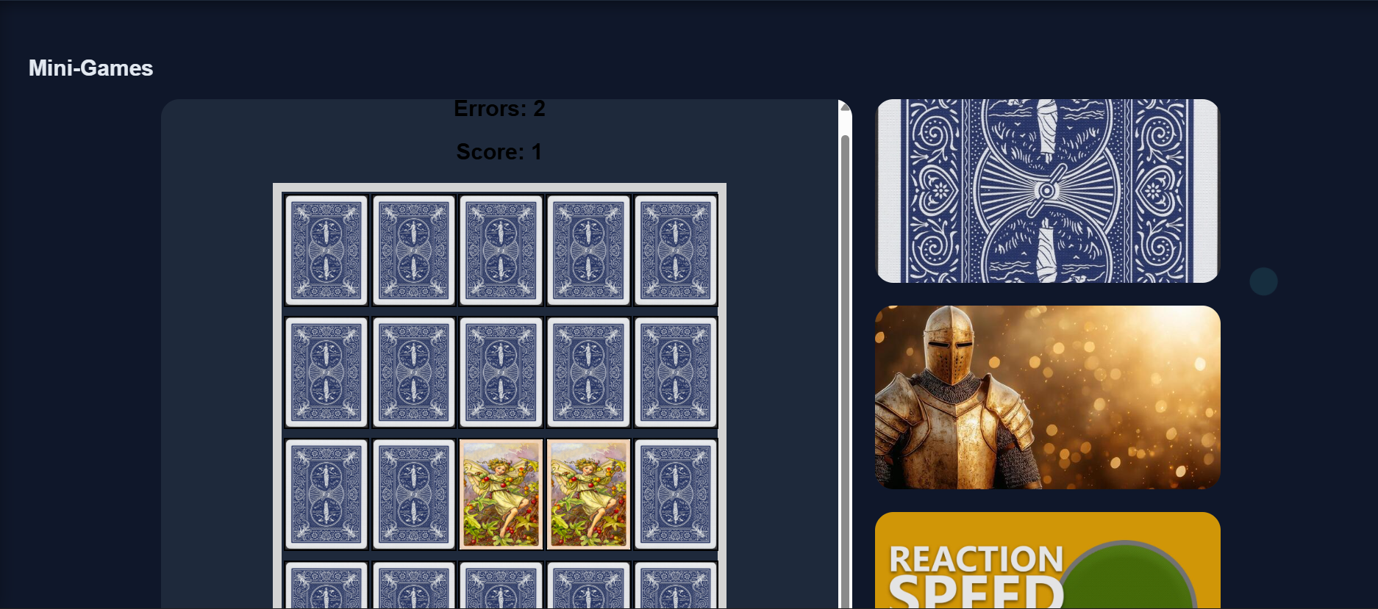
Figure V-4 Memory Card scoring system
The memory card system has error variable that updates when user make wrong choices and score variable that updates as the user make matching choices.
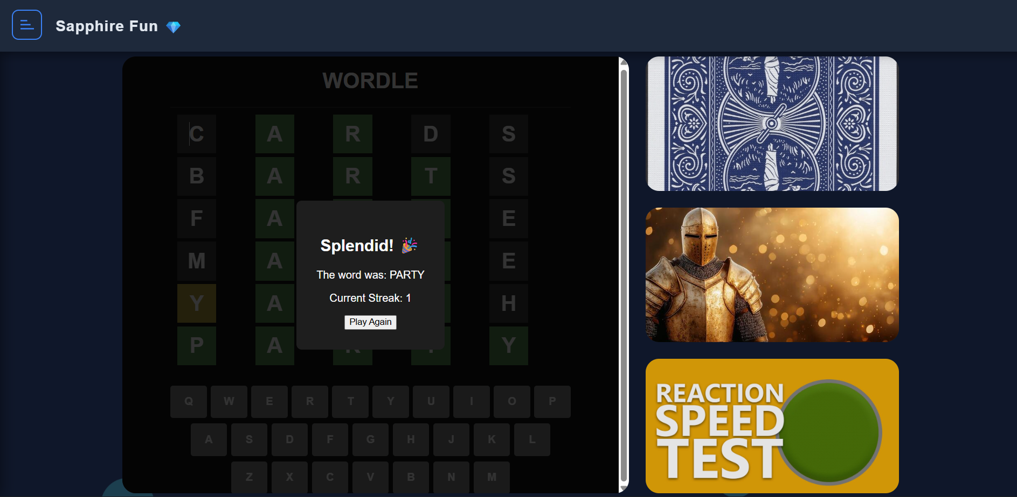
Figure V-5 Wordle Score and Streak System
These are the scoring and streak systems of games from Sapphire system that uses local storage of JavaScript.

Audio System
Audio system will be hard to describe in words and will be shown in the presentation recording to ensure the audio background in flappy cars and gameplay whack sound in whack a mole can be clearly heard.

Difficulty System
The difficulty system in the Sapphire Fun will increase and decrease the difficulty of the game. This can be found in the classic games such as sudoku and tic tac toe. In sudoku, using JavaScript the game will reduce the number of visible numbers as the difficulty increases. In tic tac toe, the difficulty will make the game harder to play using minimax algorithm. By studying minimax in YouTube and Lecture slides from AI course, JavaScript code for the best winning position for minimax was written to ensure the opponent AI lower the chance of the player’s winnings. The minimax code will be explained further in the presentation recording.

References
Development workspace GitHub - https://github.com/hlumhtetaung/Web_Technologies_Project
GitHub hosted link - https://hlumhtetaung.github.io/Web_Technologies_Project/
Note: In the workspace, you can see the development process, commits, pushes, and the reference YouTube videos where I will learn how to write code for games I mentioned.

